**VISVESVARAYA TECHNOLOGICAL UNIVERSITY**

**Jnana Sangama, Macche, Belagaum – 590018**



MINI PROJECT REPORT ON

**“E-Commerce Online Store Management System”**

**Submitted in partial fulfillment for the requirements of the mini-project work**

**Submitted by**

**ISAAC A 1AK19CS017**

**Under the guidance of**

**Mr. RAKESH S**

Assistant Professor,

Department of Computer Science and Engineering,

Akshaya Institute of Technology, Tumkur



**DEPARTMENT OF COMPUTER SCIENCE AND ENGINEERING**

**AKSHAY INSTITUE OF TECHNOLOGY**

Lingapura,Tumkur-Koratagere road, tumkur-572106

2021-22

**AKSHAYA INSTITUTE OF TECHNOLOGY**

Lingapura, Tumkur-Koratagere road,Tumkur-572106



DEPARTMENT OF COMPUTER SCIENCE AND ENGINEERING

**CERTIFICATE**

This is to certify that the Mini-project work entitled **“E-Commerce Online Store Management System”** is a bonafide work carried out at **Database management system** with mini project laboratory by **ISAAC A (1AK19CS017)** in partial fulfilment for the award of **Bachelor of Engineering in Computer Science and Engineering in 5th semester of the Visvesvaraya Technological University**, during the academic year.

**2021-2022.**

Signature of the Guide Signature of the HOD

**Prof. RAKESH S Assistant Prof. RAKESH S**

Professor, Assistant Professor,

Department of CSE, Department of CSE,

AIT, TUMKUR**.** AIT, TUMKUR.

Name of the Examiners Signature Date

1. ____________________ _____________________
2. ____________________ _____________________

**ACKNOWLEDGEMENT**

The sense of contentment and elation that accomplishes the successful of completion of our task would be incomplete without mentioning the names of the people who helped in accomplishment of this Mini-Project, whose constant guidance, support and encouragement resulted in its realization.

I take this opportunity to thank our principal, **Dr. K V Srinivas Rao** for providing us with serene and healthy environment within the college, which helped us in concentrating on our task.

I express our deep sense of gratitude to our **RAKESH S** Assistant Professor for his constant encouragement and useful suggestions in carrying out this project successful.

I thank my guide **Prof. Rakesh S** Department of CSE for having provided the necessary guidance and facilities to carry out the project.

I thank all teaching and non-teaching staff of the department of CSE, who has helped me in completing the project.

I wish to thank my friends for their useful guidance on various topics. Last, but not least, I would like to thank my **Parents** for the support.

**Isaac A**

(1AK19CS017)

**ABSTRACT**

E-Commerce Online Store Management System Project is web based application

In today’s fast-changing business environment, it’s extremely important to be able to respond to client needs in the most effective and timely manner.

If your customers wish to see your business online and have instant access to your products or services. Online Shopping is a lifestyle e-commerce web application, which retails various fashion and lifestyle products (Currently Men’s Wear).

This project allows viewing various products available enables registered users to purchase desired products instantly using PayPal payment processor (Instant Pay) and also can place order by using of these options. This project provides an easy access to Administrators and Managers to view orders placed using Pay Later and Instant Pay options.

In order to develop an e-commerce website, a number of Technologies must be studied and understood.

These include multi-tiered architecture, server and client side scripting techniques, implementation technologies such as Html, CSS, Bootstrap, PHP, programming language (JavaScript) with J-query Library and MySQL relational databases.

This is a project with the objective to develop a website where a consumer is provided with a shopping cart application and also to know about the technologies used to develop such an application.

This document will discuss the various technologies that have been used in the making of the web application

## Table of Contents

Contents

Chapter I: Introduction 1

* 1. Introduction 1
  2. Objective 1
  3. Needs of Ecommerce 2
  4. Methodology Development Model 2
  5. Tools and Technique 3

1.6.1 External Interfaces 12

Figure: Schema Diagram 18

Chapter II: Task and Activities Performed 21

* 1. Profile of Problems 21
  2. Structure of the project 21
  3. Scope and Feasibility 22
  4. System Analysis 22
  5. System Design 23
  6. Implementation 23
  7. Test Generation 24
  8. Problem Analysis 24

Chapter III: Screenshots 25

Chapter IV: Discussion and Conclusion 31

* 1. Conclusion 31
  2. Further Developments 32

3.3 References………………………………………………………………………………………..33

## Chapter I: Introduction

# Introduction

Computer plays an important role in our daily life. Anything we want we can get only in one mouse click. Speed, reliability and accuracy of the computer make it a powerful tool for different purposes. A very important and basic need of today’s modern business world is the quick availability and processing of information using computer. One can easily get the type of required information within a fraction of a second. The project that I have taken is also in this category which is used in our daily life whenever we want to purchase some items we can easily get them at our home.

E-commerce (electronic commerce) is the buying and selling of goods and services, or the transmitting of funds or data, over an electronic network, primarily the internet. These business transactions occur either as business-to-business ([B2B](https://searchcio.techtarget.com/definition/B2B)), business-to-consumer ([B2C](https://searchcustomerexperience.techtarget.com/definition/B2C)), consumer- to-consumer or consumer-to-business. The terms e-commerce and e-business are often used interchangeably. The term e-tail is also sometimes used in reference to the [transactional](https://searchcio.techtarget.com/definition/transaction) [processes](https://searchcio.techtarget.com/definition/transaction) for online shopping.

# Objective

Developing a GUI based automated system, which will cover all the information Related to the all products which is used in our daily life. For example – Mobiles Phones, Laptops, Clothes, Books, Electronic Items and many more. So by this GUI based automated system a user want to purchase something then it only a mouse click away to purchase these products.

The e-commerce is mainly useful for ho haven’t time to go shopping or for comfortably to the customers. Those are just entered into this website and bought they want at any time they can visit the web-site.

Customer will choose different items like mobile, laptops, etc. This website is based on this formal. After chosen items they pay bill thorough pay pal process. Customer will get their items just sitting at home.

# Needs of Ecommerce

## The “**Ecommerce**” is developed according the current need in different Fields. This is Ecommerce Website which provides facility for purchasing Mobiles, Laptops, tabs and many more items. So by using this system users which want to purchase some products will first Register an account on this portal then Login through their Username and Password, and then Select items which they want to purchase and add them to cart and finally checkout by giving payment details. So by using this portal users can easily purchase products from their home.

# Methodology Development Model

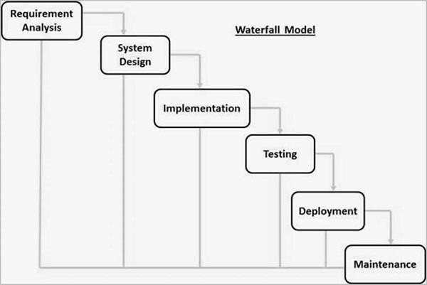

The sequential phases in Waterfall model are –

**Requirement Gathering and analysis** − All possible requirements of the system to be developed are captured in this phase and documented in a requirement specification document.

* + - **System Design** − The requirement specifications from first phase are studied in this phase and the system design is prepared. This system design helps in specifying hardware and system requirements and helps in defining the overall system architecture.
* **Implementation** − With inputs from the system design, the system is first developed in small programs called units, which are integrated in the next phase. Each unit is developed and tested for its functionality, which is referred to as Unit Testing.
  + - **Integration and Testing** − All the units developed in the implementation phase are integrated into a system after testing of each unit. Post integration the entire system is tested for any faults and failures.
    - **Deployment of system** − Once the functional and non-functional testing is done; the product is deployed in the customer environment or released into the market.
    - **Maintenance** − There are some issues which come up in the client environment. To fix those issues, patches are released. Also to enhance the product some better versions are released. Maintenance is done to deliver these changes in the customer environment.

# Tools and Technologies Used:

1. HTML5
2. CSS
3. JavaScript & J-Query
4. AJAX(Asynchronous JavaScript & XML)
5. Bootstrap
6. PHP
7. XAMPP Server
8. VS Code
9. GitHub & Git Version Controlling System

**HTML5:**

Hypertext Markup Language (HTML) is the standard [markup language](https://en.wikipedia.org/wiki/Markup_language) for creating [web pages](https://en.wikipedia.org/wiki/Web_page) and [web](https://en.wikipedia.org/wiki/Web_application) [applications.](https://en.wikipedia.org/wiki/Web_application) With [Cascading Style Sheets](https://en.wikipedia.org/wiki/Cascading_Style_Sheets) (CSS) and [JavaScript](https://en.wikipedia.org/wiki/JavaScript), it forms a triad of cornerstone technologies for the [World Wide Web](https://en.wikipedia.org/wiki/World_Wide_Web)[.[4]](https://en.wikipedia.org/wiki/HTML#cite_note-4)

[Web browsers](https://en.wikipedia.org/wiki/Web_browser) receive HTML documents from a [web server](https://en.wikipedia.org/wiki/Web_server) or from local storage and [render](https://en.wikipedia.org/wiki/Browser_engine) the documents into multimedia web pages. HTML describes the structure of a web page [semantically](https://en.wikipedia.org/wiki/Semantic_Web) and originally included cues for the appearance of the document.

[HTML elements](https://en.wikipedia.org/wiki/HTML_element) are the building blocks of HTML pages. With HTML constructs, [images](https://en.wikipedia.org/wiki/HTML_element#Images_and_objects) and other objects such as [interactive forms](https://en.wikipedia.org/wiki/Fieldset) may be embedded into the rendered page. HTML provides a means

Create [structured documents](https://en.wikipedia.org/wiki/Structured_document) by denoting structural [semantics](https://en.wikipedia.org/wiki/Semantics) for text such as headings Paragraphs , lists, [links,](https://en.wikipedia.org/wiki/Hyperlink) quotes and other items.

HTML 5 is the fifth and current version of HTML. It has improved the mark up available for documents and has introduced application programming interfaces (API) and Document Object Model (DOM).

Features:

* It has introduced new multimedia features which supports audio and video controls by using <audio> and <video> tags.
* There are new graphics elements including vector graphics and tags.
* Enrich semantic content by including <header> <footer>, <article>, <section> and <figure> are added.
* Drag and Drop- The user can grab an object and drag it further dropping it on a new location.
* Geo-location services- It helps to locate the geographical location of a client.
* Web storage facility which provides web application methods to store data on web browser.
* Uses SQL database to store data offline.
* Allows to draw various shapes like triangle, rectangle, circle, etc.
* Capable of handling incorrect syntax.
* Easy DOCTYPE declaration i.e. <!doctype html>
* Easy character encoding i.e. <meta charset=”UTF-8″>

**CSS :**

Cascading Style Sheets, fondly referred to as CSS, is a simple design language intended to simplify the process of making web pages presentable.

CSS is created and maintained through a group of people within the W3C called the CSS Working Group. The CSS Working Group creates documents called specifications

CSS handles the look and feel part of a web page. Using CSS, you can control the color of the text, the style of fonts, the spacing between paragraphs, how columns are sized and laid out, what background images or colors are used, layout designs and variations in display for different devices and screen sizes as well as a variety of other effects.

CSS is easy to learn and understand but it provides powerful control over the presentation of an HTML document. Most commonly, CSS is combined with the markup languages HTML or XHTML.

Advantages of CSS

CSS saves time − you can write CSS once and then reuse same sheet in multiple HTML pages. You can define a style for each HTML element and apply it to as many Web pages as you want.

Pages load faster − If you are using CSS, you do not need to write HTML tag attributes every time. Just write one CSS rule of a tag and apply it to all the occurrences of that tag. So less code means faster download times.

Easy maintenance − To make a global change, simply change the style, and all elements in all the web pages will be updated automatically.

Superior styles to HTML − CSS has a much wider array of attributes than HTML, so you can give a far better look to your HTML page in comparison to HTML attributes.

Multiple Device Compatibility − Style sheets allow content to be optimized for more than one type of device. By using the same HTML document, different versions of a website can be presented for handheld devices such as PDAs and cell phones or for printing.

Global web standards − Now HTML attributes are being deprecated and it is being recommended to use CSS. So its a good idea to start using CSS in all the HTML pages to make them compatible to future browsers.

**Java Script**

JavaScript (often shortened to JS) is a lightweight, interpreted, object-oriented language with [first-class functions](https://en.wikipedia.org/wiki/First-class_function), and is best known as the scripting language for Web pages, but it's [used in many non-browser environments](https://en.wikipedia.org/wiki/JavaScript#Uses_outside_Web_pages) as well.

It is a [prototype-based](https://en.wikipedia.org/wiki/Prototype-based_programming), multi-paradigm scripting language that is dynamic, and supports object-oriented, imperative, and functional programming styles.

The basic syntax is intentionally similar to both Java and C++ to reduce the number of new concepts required to learn the language. Language constructs, such as if statements, for and while loops, and switch and try ... catch blocks function the same as in these languages (or nearly so).

Once an object has been constructed it can be used as a blueprint (or prototype) for creating similar objects.JavaScript's dynamic capabilities include runtime object construction, variable parameter lists, function variables.

Dynamic script creation (via [eval](https://developer.mozilla.org/en-US/docs/Web/JavaScript/Reference/Global_Objects/eval)), object introspection (via for ... in), and source code recovery (JavaScript programs can decompile function bodies back into their source text).

**J-Query:**

J-Query is a fast, small, and feature-rich JavaScript library.

It makes things like HTML document traversal and manipulation, event handling, animation, and Ajax much simpler with an easy-to-use API that works across a multitude of browsers.

With a combination of versatility and extensibility.

J-Query has changed the way that millions of people write JavaScript.

**AJAX:**

AJAX = Asynchronous JavaScript and XML.

AJAX is a technique for creating fast and dynamic web pages.

AJAX allows web pages to be updated asynchronously by exchanging small amounts of data with the server behind the scenes. This means that it is possible to update parts of a web page, without reloading the whole page.

Classic web pages, (which do not use AJAX) must reload the entire page if the content should change

**PHP:**

PHP (recursive acronym for PHP: Hypertext Preprocessor) is a widely-used open source general- purpose scripting language that is especially suited for web development and can be embedded into HTML.

PHP is mainly focused on server-side scripting, so you can do anything any other CGI program can do, such as collect form data, generate dynamic page content, or send and receive cookies. But PHP can do much more.

There are three main areas where PHP scripts are used.

Server-side scripting. This is the most traditional and main target field for PHP. You need three things to make this work: the PHP parser (CGI or server module), a web server and a web browser. You need to run the web server, with a connected PHP installation.

You can access the PHP program output with a web browser, viewing the PHP page through the server. All these can run on your home machine if you are just experimenting with PHP programming. See the [installation instructions](https://www.php.net/manual/en/install.php) section for more information.

Command line scripting. we can make a PHP script to run it without any server or browser. You only need the PHP parser to use it this way. This type of usage is ideal for scripts regularly executed using cron (on *nix or Linux) or Task Scheduler (on Windows).

These scripts can also be used for simple text processing tasks. See the section about [Command line usage of PHP](https://www.php.net/manual/en/features.commandline.php) for more information.

Writing desktop applications. PHP is probably not the very best language to create a desktop application with a graphical user interface, but if you know PHP very well, and would like to use some advanced PHP features in your client-side applications you can also use PHP-GTK to write such programs.

You also have the ability to write cross-platform applications this way. PHP-GTK is an extension to PHP, not available in the main distribution. If you are interested in PHP-GTK, visit [» its own website](http://gtk.php.net/).

PHP can be [used](https://www.php.net/manual/en/install.php) on all major operating systems, including Linux, many Unix variants (including HP-UX, Solaris and OpenBSD), Microsoft Windows, macOS, RISC OS, and probably others. PHP also has support for most of the web servers today.

With PHP you are not limited to output HTML. PHP's abilities includes outputting images, PDF files and even Flash movies (using libswf and Ming) generated on the fly. You can also output easily any text, such as XHTML and any other XML file.

PHP can auto generate these files, and save them in the file system, instead of printing it out, forming a server-side cache for your dynamic content.

**MySQL:**

MySQL Workbench is a unified visual tool for database architects, developers, and DBAs.

MySQL is a database system used on the web

MySQL is a database system that runs on a server

MySQL is ideal for both small and large applications

MySQL is very fast, reliable, and easy to use

MySQL uses standard SQL

MySQL compiles on a number of platforms

MySQL is free to download and use

MySQL is developed, distributed, and supported by Oracle Corporation

MySQL is named after co-founder Monty Widenius's daughter: My

The data in a MySQL database are stored in tables.

A table is a collection of related data, and it consists of columns and rows.

MySQL Workbench provides data modeling, SQL development, and comprehensive administration tools for server configuration, user administration,

Backup, and much more.

MySQL Workbench is available on Windows, Linux and Mac OS X.

PHP combined with MySQL are cross-platform (you can develop in Windows and serve on a Unix platform)

**XAMPP**

XAMPP is one of the widely used cross-platform web servers, which helps developers to create and test their programs on a local webserver. It was developed by the **Apache Friends**

1. Cross-Platform: Different local systems have different configurations of operating systems installed in it. The component of cross-platform has been included to increase the utility and audience for this package of Apache distributions. It supports various platforms such as packages of Windows, Linus, and MAC OS.
2. Apache: It is an HTTP a cross-platform web server. It is used worldwide for delivering web content. The server application has made free for installation and used for the community of developers under the aegis of Apache Software Foundation. The remote server of Apache delivers the requested files, images, and other documents to the user.
3. MariaDB: Originally, MySQL DBMS was a part of XAMPP, but now it has been replaced by MariaDB. It is one of the most widely used relational DBMS, developed by MySQL. It offers online services of data storage, manipulation, retrieval, arrangement, and deletion.
4. PHP: It is the backend scripting language primarily used for web development. PHP allows users to create dynamic websites and applications. It can be installed on every platform and supports a variety of database management systems. It was implemented using C language. PHP stands for Hypertext Processor. It is said to be derived from Personal Home Page tools, which explains its simplicity and functionality.
5. phpMyAdmin: It is a tool used for dealing with MariaDB. Its version 4.0.4 is currently being used in XAMPP. Administration of DBMS is its main role.
6. XAMPP Control Panel: It is a panel that helps to operate and regulate upon other components of the XAMPP. Version 3.2.1 is the most recent update. A detailed description of the control panel will be done in the next section of the tutorial.
7. Tomcat: Version 7.0.42 is currently being used in XAMPP. It is a servlet based on JAVA to provide JAVA functionalities.
8. Filezilla: It is a File Transfer Protocol Server, which supports and eases the transfer operations performed on files. Its recently updated version is 0.9.41.

**Bootstrap**

Bootstrap was developed by Mark Otto and Jacob Thornton at Twitter. It was released as an open source product in August 2011 on GitHub.

Mark Otto and Jacob Thornton developed Bootstrap at Twitter as a means of improving the consistency of tools used on the site and reducing maintenance.

The software was formerly known as Twitter Blueprint and is sometimes referred to as Twitter Bootstrap.

Responsive design makes it possible for a web page or app to detect the visitor’s screen size and orientation and automatically adapt the display accordingly.

The mobile first approach assumes that smartphones, tablets and task-specific Mobile apps are employees' primary tools for getting work done and addresses the requirements of those technologies in design.

Bootstrap includes user interface components, layouts and JS tools along with the framework for implementation.

The software is available precompiled or as source code

* Bootstrap is the most popular HTML, CSS and JavaScript framework for developing a responsive and mobile friendly website.
* It is absolutely free to download and use.
* It is a front-end framework used for easier and faster web development.
* It includes HTML and CSS based design templates for typography, forms, buttons, tables, navigation, modals, image carousels and many others.
* It can also use JavaScript plug-ins.
* It facilitates you to create responsive designs.
* It is very easy to use. Anybody having basic knowledge of HTML and CSS can use Bootstrap.
* It facilitates users to develop a responsive website.
* It is compatible on most of browsers like Chrome, Firefox, Internet Explorer, Safari and Opera etc.

**VS Code**

**Visual Studio Code** (famously known as **VS Code**) is a free open source text editor by Microsoft. VS Code is available for Windows, Linux, and macOS.

Although the editor is relatively lightweight, it includes some powerful features that have made VS Code one of the most popular development environment tools in recent times.

VS Code supports a wide array of programming languages from Java, C++, and Python to CSS, Go, and Docker file. Moreover, VS Code allows you to add on and even creating new extensions including code linters, debuggers, and cloud and web development support.

The VS Code user interface allows for a lot of interaction compared to other text editors.

**GitHub & git:**

GitHub is a web-based [hosting service](https://en.wikipedia.org/wiki/Internet_hosting_service) for [version control](https://en.wikipedia.org/wiki/Version_control) using [Git.](https://en.wikipedia.org/wiki/Git) It is mostly used for [computer code.](https://en.wikipedia.org/wiki/Source_code)

It offers all of the [distributed version control](https://en.wikipedia.org/wiki/Distributed_version_control) and [source code management](https://en.wikipedia.org/wiki/Source_code_management) (SCM) functionality of Git as well as adding its own features.

It provides [access control](https://en.wikipedia.org/wiki/Access_control) and several collaboration features such as [bug](https://en.wikipedia.org/wiki/Bug_tracking_system)-t[racking,](https://en.wikipedia.org/wiki/Bug_tracking_system) [feature requests,](https://en.wikipedia.org/wiki/Software_feature) [task management,](https://en.wikipedia.org/wiki/Task_management) and [wikis](https://en.wikipedia.org/wiki/Wiki) for every project.

GitHub offers plans for both private repositories and free accounts which are commonly used to host [open-](https://en.wikipedia.org/wiki/Open-source) [source](https://en.wikipedia.org/wiki/Open-source) software projects.

Git is a **specific open-source version control system** created by Linus Torvalds in 2005.

Specifically, Git is a **distributed version control system**, which means that the entire codebase and history is available on every developer’s computer, which allows for easy branching and merging.

# Specification Requirement

## External Interfaces

- This interface will be actual interface through which the user will communication with the application and perform the desired tasks.

Admin login

### D:

**Role**: Admin wishes to login to the system

**Precondition**: Username and Password

**Success end Condition**: Main option of screen display

**Failed end Condition**: User has entered incorrect Username and Password or both

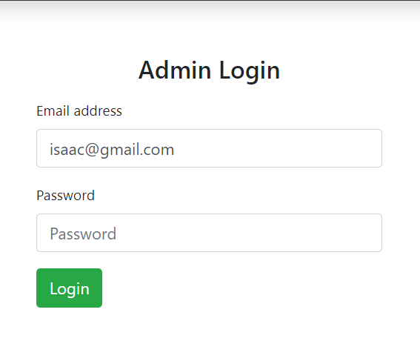

* + 1. Software Product Features

Ecommerce system

Login Information System

* Description

-The system will maintain the login information of its user to enter in to the software

* Validating Checks

-Administrator need to login the unique id and password.

-Contact number should have maximum 10 digits.

-All the details must be fill up.

-Email address should be in the proper format.

* Sequencing information

-Login information should be filled before the user allowed.

* Error Handling

-If user doesn’t filled up validate information then the system display error message for user and request to enter the validate information.

Performance required

* Security

-System should be Protected from unauthorized access Where the validate Username and Password are required so no other can access.

* Maintainability

-System should be design in a maintain order. So it can be easily modified.

Logical Database

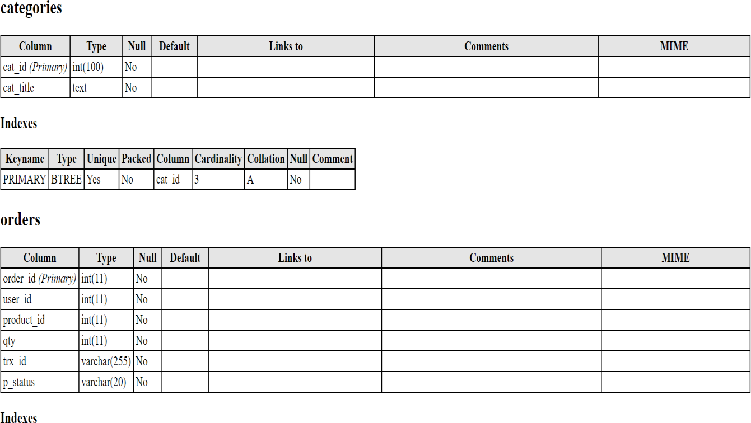

Data Design

Data Model: A database model is a type of data model that determines the logical structure of a database and fundamentally determines in which manner data can be stored, organized and manipulated.

Level 0

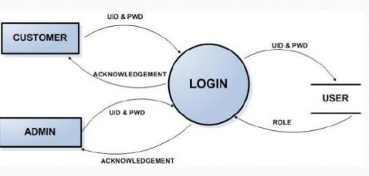

Figure: Data flow

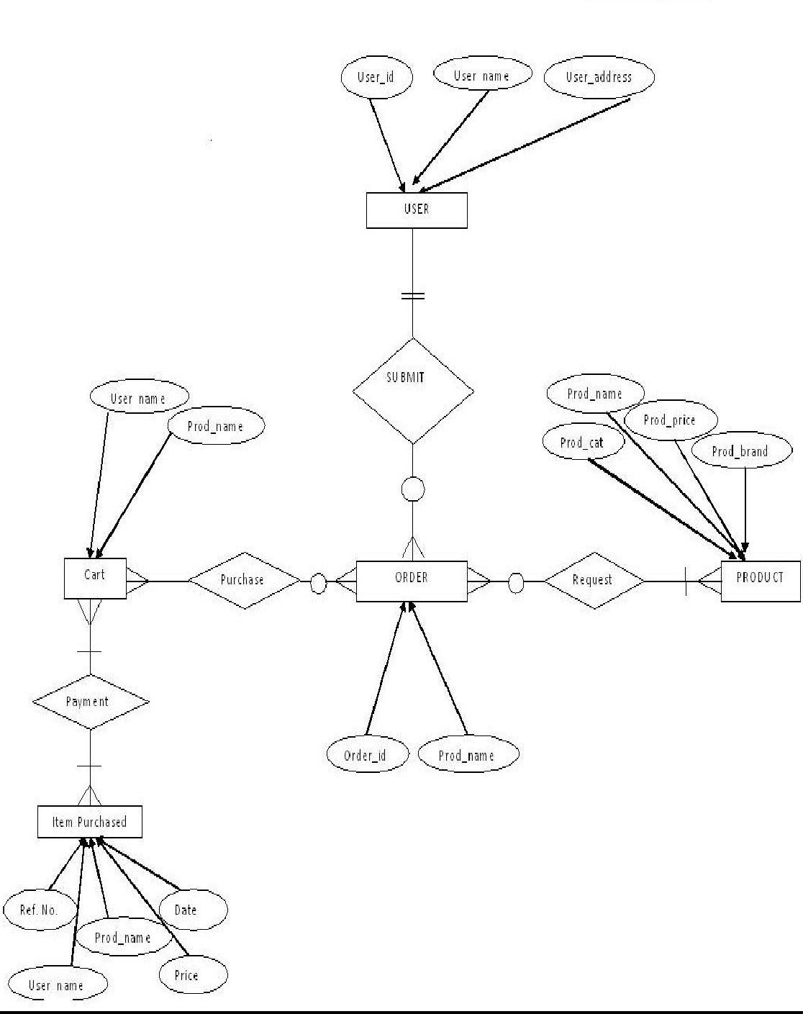

Figure: E-R diagram

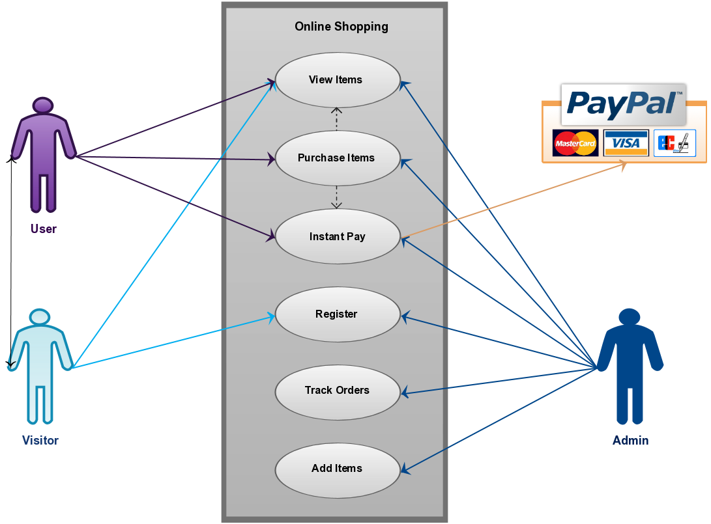

Figure: Use case Diagram of Ecommerce

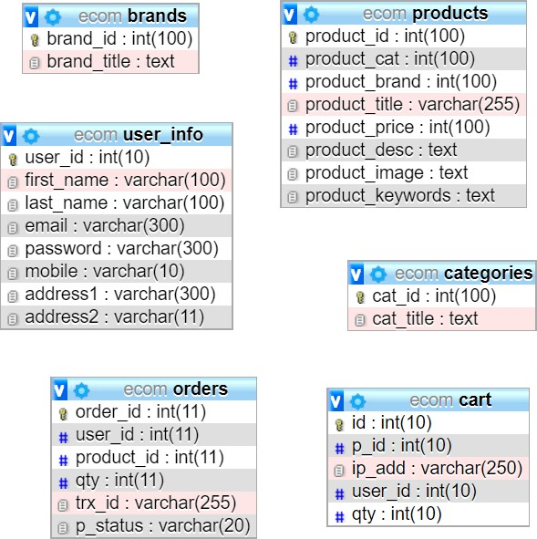

**Figure: Schema Diagram**

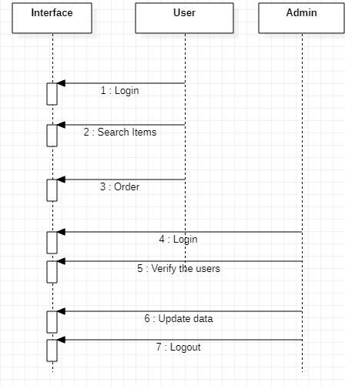

Figure: Sequence Diagram

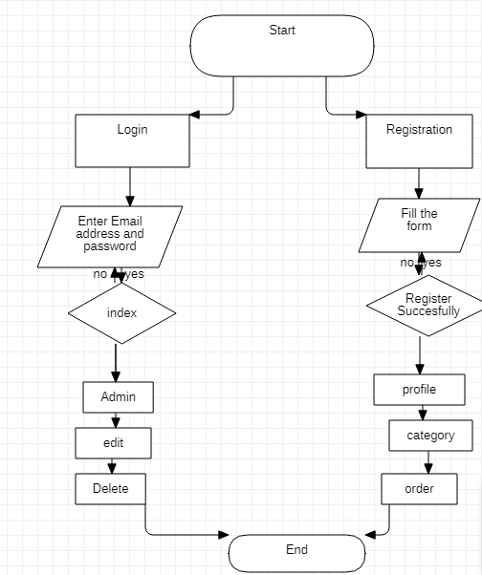

Figure: Flowchart of Ecommerce

## Chapter II: Task and Activities Performed

# Profile of Problems

One must know what the problem is before it can be solved. The basis for ecommerce is to buy products online and save the timing.

A Ecommerce, who want to buy any product of their need, has to contact different Shoppers, before deciding upon a particular Product that best suit his needs, requirements and satisfaction. Moreover, most of the work involved in this development process has to be done manually which is very time consuming and cumbersome and also, it reduces the efficiency, accuracy.

To know the facts and understanding of the problem in detail, ***System Analysis*** is carried out. It is the process of studying the business processes and procedures, generally referred to as business systems, to see how they can operate and whether improvement is needed.

# Structure of the project

* Before Login
  + Login
  + Register
  + Forget Password
  + Administrator Login
  + About Us
  + Contact Us
* After Administrator Login
  + Edit Website Details
  + Add Brands
  + Add Category
  + Add Items
  + Delete Brands
  + Delete Category
  + Delete Items
  + Manage User
    - See Users
    - Users Shopping
    - Add Users
    - Delete Users
  + Logout
* After User Login
  + My Profile
    - Edit Profile
    - Change Password
  + Buy Products
    - Categories (Controlled by Admin. Which can be add it dynamically according to their needs)
  + My Cart
  + My Shopping’s
  + Checkout
  + Logout

# Scope and Feasibility

This activity is also known as the feasibility study. It begins with a request from the user for a new system. It involves the following:

* + - Identify the responsible user for a new system
    - Clarify the user request
    - Identify deficiencies in the current system
    - Establish goals and objectives for the new system
    - Determine the feasibility for the new system
    - Prepare a project charter that will be used to guide the remainder of the Project

# System Analysis

The objective of the system analysis activity is to develop structured system specification for the proposed system. The structured system specification should describe what the proposed system would do; independent of the technology, which will be used to implement these requirements. The structured system specification will be used to implement these requirements. The structured system specification will be called the essential model (also know as logical model).

The essential model may itself consist of multiple models, modeling different aspect of the system. The data flow diagrams may model the data and there relationships and the state transition diagram may model time dependent behavior of the system. The essential model thus consists of the following.

## Context diagram

* + - Leveled data flow diagrams
    - Process specification for elementary bubbles
    - Data dictionary for the flow and stores on the DFDs.

# System Design

System design involves transformation of the user implementation model into software design. The design specification of the proposed system consists of the following:

* + - Database scheme
    - Structure charts
    - Pseudo codes for the modules in structure charts

# Implementation

This activity includes programming, testing and integration of modules into a progressively more complete system. Implementation is the process of collect all the required parts and assembles them into a major product.

# Test Generation

This activity generates a set of test data, which can be used to test the new system before accepting it. In the test generation phase all the parts are come which are to be tested to ensure that system does not produce any error. If there are some errors then we remove them and further it goes for accepting.

# Problem Analysis

Ecommerce system is a computerized, online solution to the various problems faced by the Product buyer and seller wishing to outsource their software development work to a Provider at an economical cost, thus achieving high performance, accuracy, reliability and high speed of data retrieval.

In this system, there is a registration process each for the Product buyer and seller. The Administrator of the site verifies the Provider after his registration and if satisfied, assigns him a user name and password.

Our site can be used by anyone who is searching for Products whether he/she is first time visiting our site. Our site also provides some discounted Products as same u get on any shop.

**The software covers the following point while keeping in mind user’s requirement-:**

* + - Fast online access of information about various Products.
    - Search Products by keywords like functional area, experience and also by initials of the Product’s name.
    - Administrator will maintain the database and perform all process.

**There are 2 categories of users-**

1. General User
2. Registered Users
3. **Structural Representation of application with Snapshots:**

Anyone can view Online Shopping portal and available products, but every user must login by his/her Username and password in order to purchase or order products. Unregistered members can register by navigating to registration page. Only Admin will have access to modify roles, by default developer can only be an ‘Admin’. Once user register site, his default role will be ‘User’.

* + 1. User Registration: User Will Register by providing the Suitable Details in the registration form

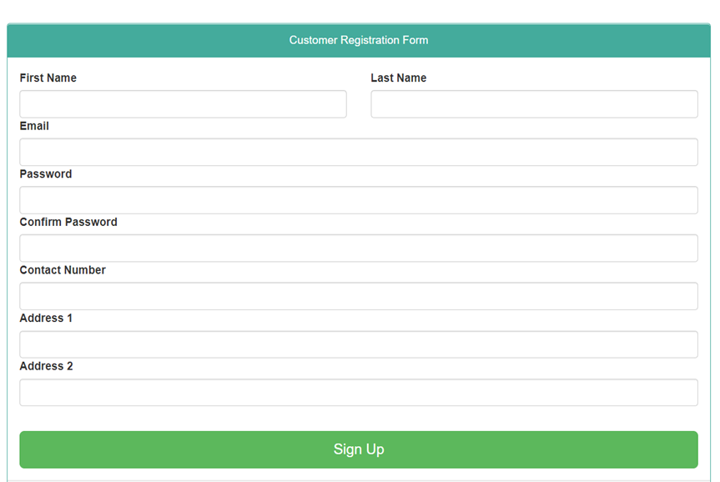

3.0.2 User Login: User can login by providing the details that has been registered

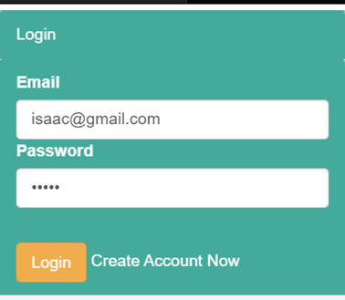

* + 1. Homepage: The Home Screen will consist of screen were one can browse through the products which we have on our web Application.

Can Browse through the Brands and Categories

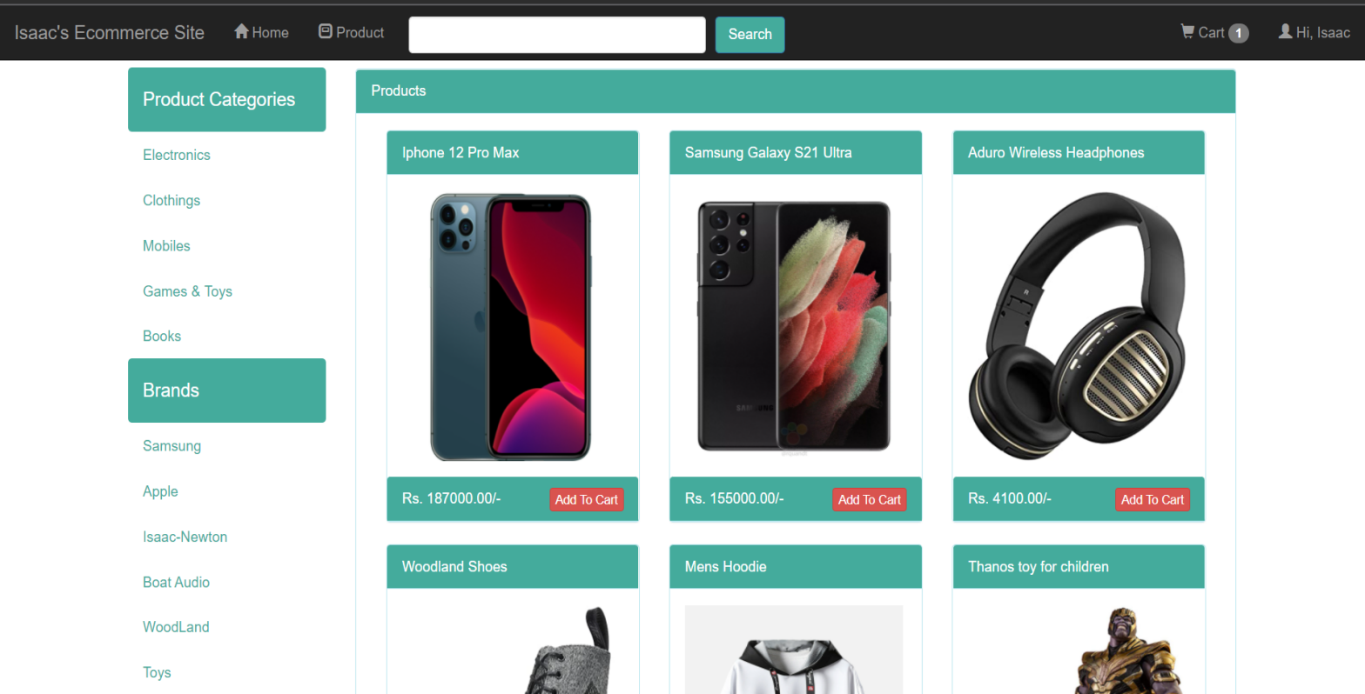

* + 1. Cart: Consists of all the products that have been added into the cart we can delete or increase the quantity of the product and we get the display of the total cost at the bottom with the payment option

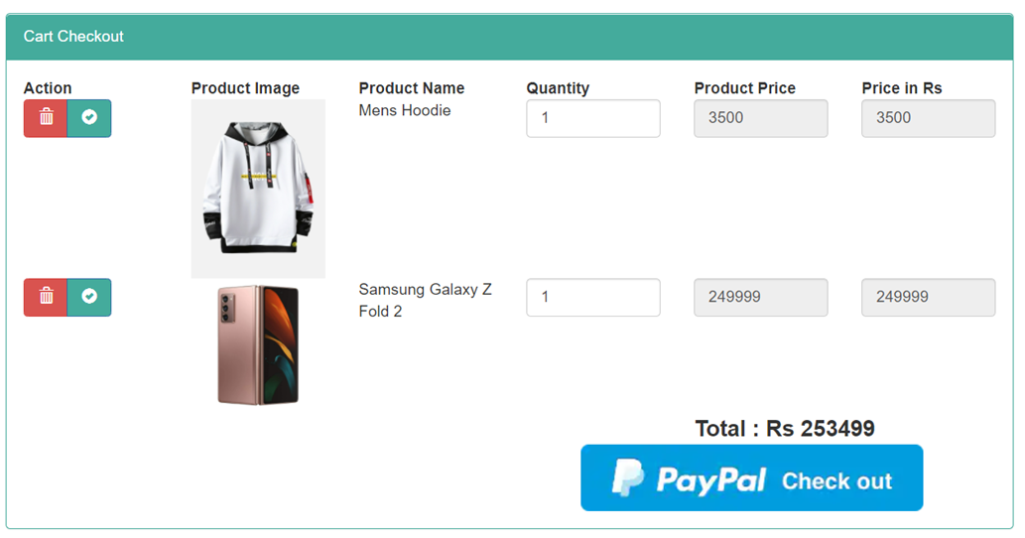

3.0.5 PayPal Payment Gateway:

I have used the Sand Box PayPal Payment Gateway API for Developers In the project using which we can use for the payment which accepts all kind of Payment methods

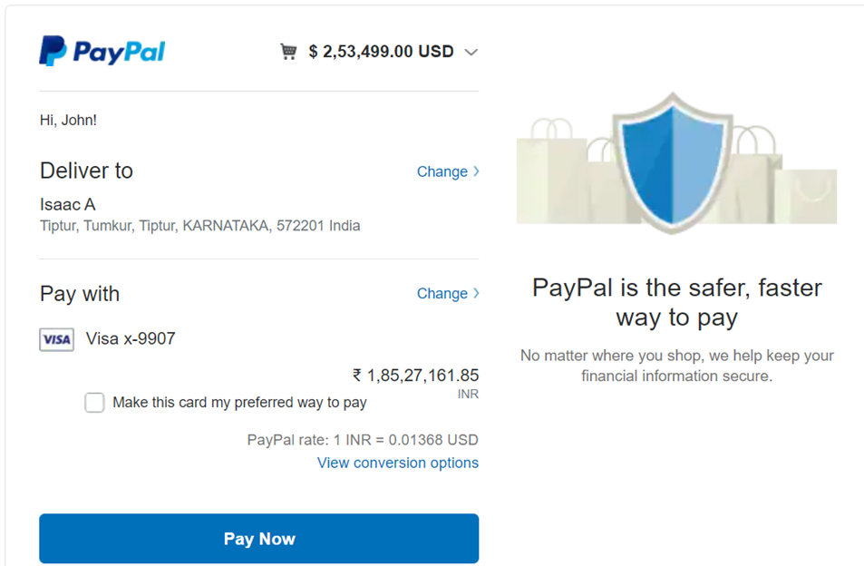

After Completion the Order Would Be placed Successfully



3.0.6 Admin Registration:

The Admin for the website can register in the admin registration by filling essential credentials

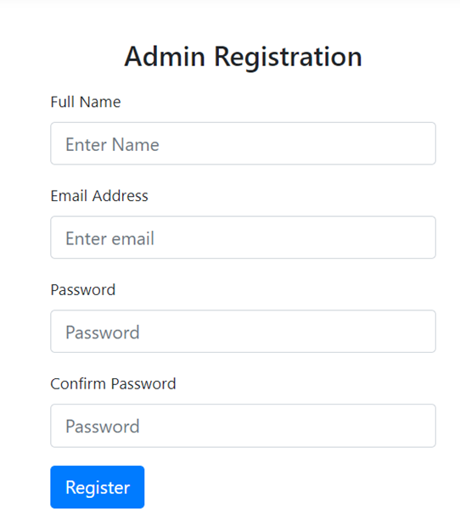

3.0.7 Admin Login: By providing the correct credentials you can login to the admin dashboard



3.0.8 Admin Dashboard:

This is the Admin dashboard which contains all the tools for managing the E-commerce Online Store Management

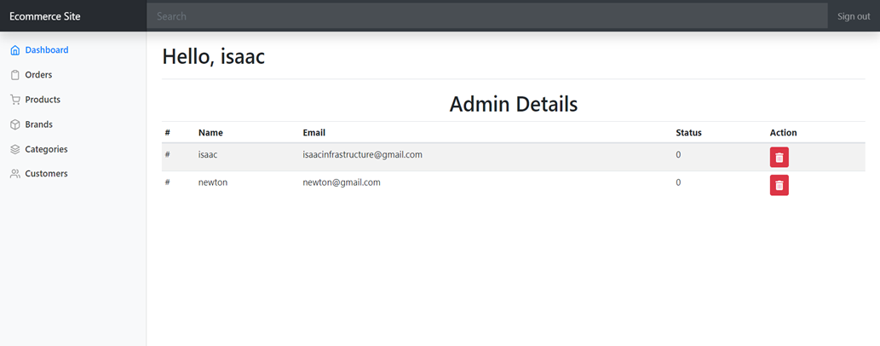

3.0.9 Here Admin can see the details of all the Orders that have been placed successfully

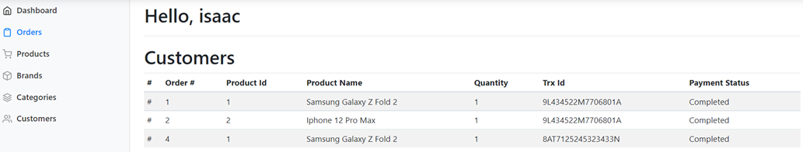

3.1.0 Admin Can manage The Products change the details of the product or delete the product or Add New Product

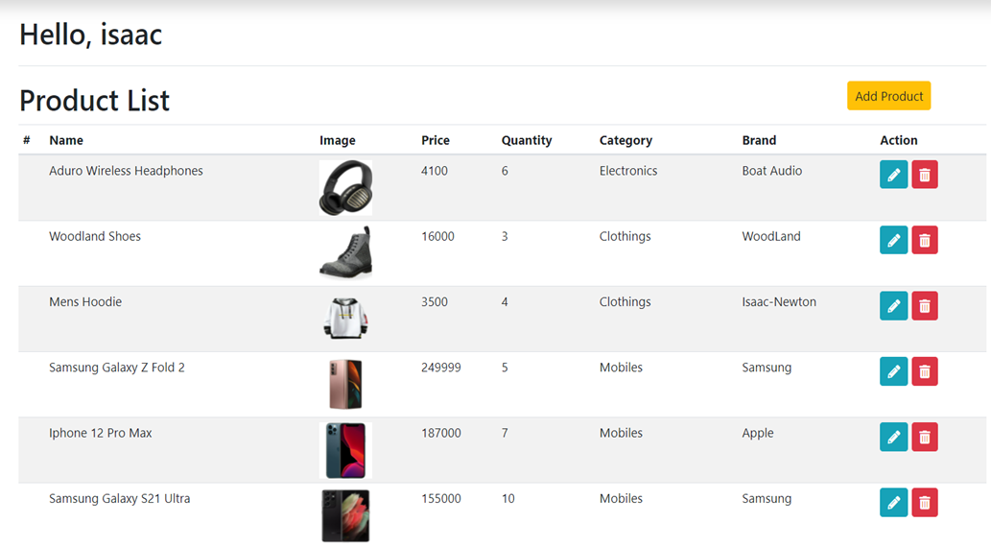

3.1.1 Admin can Manage the category add delete or create a Category for products

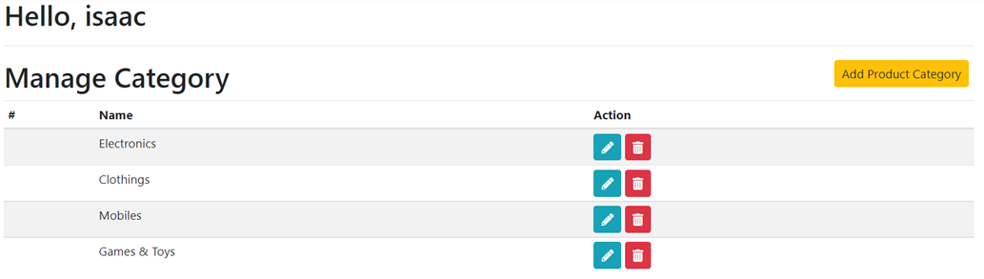

3.1.2 Admin can see the list and details of all the customers

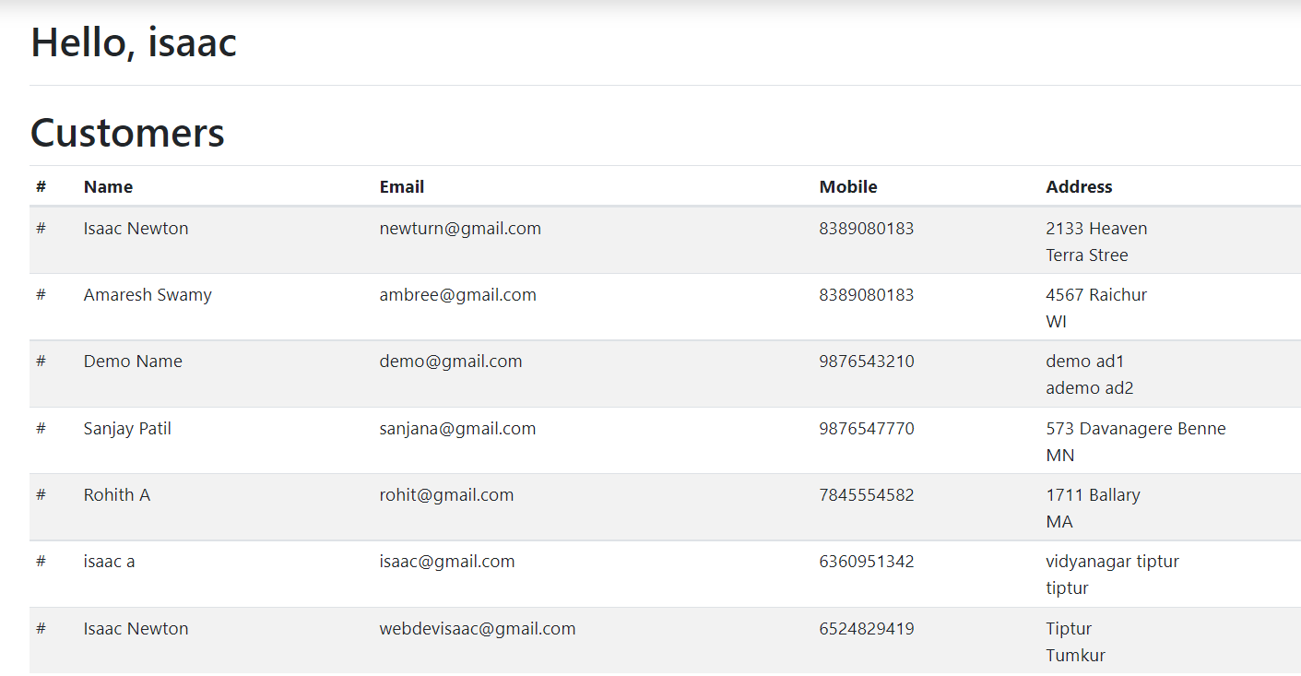

## Chapter VI: Discussion and Conclusion

# Conclusion

The E-commerce Online store Management System with the primary goal of helping people for easy online E-commerce transactions and Management To conclude the description about the project: The project, developed using PHP and MySQL is based on the requirement specification of the user and the analysis of the existing system, with flexibility for future enhancement. The expanded functionality of today’s software requires an appropriate approach towards software development. This ecommerce software is designed E- commerce site project is developed using PHP, CSS, Bootstrap, and JavaScript. Talking about the project, it has all the required essential features. This project has a user side where he/she can view product category and add products to cart and proceed for checkout whereas from administration side he/she can view sales, number of product, users, daily sales report, add product and categories. The user can also leave comments on each product if he/she wants. In this project, all the main functions are performed from the Admin side. User Friendly.

* + 1. **Further development**
* Adding Original payment Gateway from PayPal
* Adding Supply chain management system inside the application
* Adding Advanced Searching Algorithms and Implementing some more stuff

**REFERENCES:**

1. **JavaScript and JQuery: Interactive Front-End Web Development**

Book by Jon Duckett

**2) Ajax: The Complete Reference**

Book by Thomas Powell

1. **Learning PHP, MySQL & JavaScript with j Query, CSS & HTML5 Paperback – 2022**

By Robin Nixon

1. **YouTube Channels:**

* **Code With Harry**
* **Fire ship**
* **Traversy Media**
* **Apni kaksha**

1. **Websites**

* [**https://webdevsimplified.com**](https://webdevsimplified.com)
* [**https://freecodecamp.org**](https://freecodecamp.org)
* [**https://w3schools.com**](https://w3schools.com)
* [**https://codeacademy.com**](https://codeacademy.com)
* [**https://stackoverflow.com**](https://stackoverflow.com)